GEF IV FACTSHEET
WHAT
EvalPartners Global Evaluation Forum IV | Leading Progressive and Contemporary Evaluation Practice
WHEN
26-29 February 2024
26 Feb | Pre-forum workshops
27-28 Feb | Two-day GEF event
29 Feb | EvalPartners and IOCE internal affairs
WHERE
Rabat, Morocco
WHY
The IV EvalPartners Global Evaluation Forum presents an exciting opportunity for EvalPartners and the
wider evaluation community to craft a new EvalAgenda 2030, unpack and push forward key evaluation
themes, including widening and leveraging partnership, and actioning the latest UN Resolution (A/RES/77/283) for evaluation of the SDGs (adopted in 2023).
WHO
The Forum is organised by the IOCE and EvalPartners, together with the national VOPE in Morocco
Association Marocaine d'Évaluation (AME) and other stakeholders such as governments, UN Agencies, VOPEs and key partners, including the Ministry of Foreign Affairs of Finland and the German Institute for Development Evaluation (DeVAL). In Marocco, the Moroccan Parliament, the Ministry of Investment, Convergence and Evaluation of Public Policies, the High Commission for Planning and other departments have given their full support, with a session to be hosted inside the Moroccan Parliament.
HOW
The GEF is not a regular conference. It is a Forum that brings together Evaluation partners (within EvalPartners and the wider evaluation and development community) to set the stage for the future of evaluation practice. EvalPartners with key partners collectively shape the Global Evaluation Agenda to reflect on actioning the new UN Resolution (Resolution A/RES/77/283 on country-led evaluation of the SDGs).
The GEF creates a platform where key partners bring (a) institutional expertise and knowledge, and (b) national/regional representation and expertise. The former entails contributing through panels, working groups or workshops within the programme, while the latter may be by supporting national or regional players in the evaluation communities (VOPEs, governments, and institutions at national/ regional levels).
In a participatory process, EvalPartners creates linkages with partners expressing interest in the GEF IV themes so that collectively the Forum participants co-create and shape the format of engagement, organized to maximize interaction and engagement pre- and during the Forum.
Interested partners can support the Forum through:
- Supporting participants (VOPEs, network members and national/ regional counterparts) to attend the GEF
- Sponsoring bursaries for young and emerging evaluators
- Contributing to the co-creation of the programme by leading and supporting workshops and panels on themes of interest
- Delegating senior leadership as keynote speakers
- Mobilising national and regional government partners
- Supporting publicity, communications and advocacy, as well as administration, and direct financial support
THE AGENDA
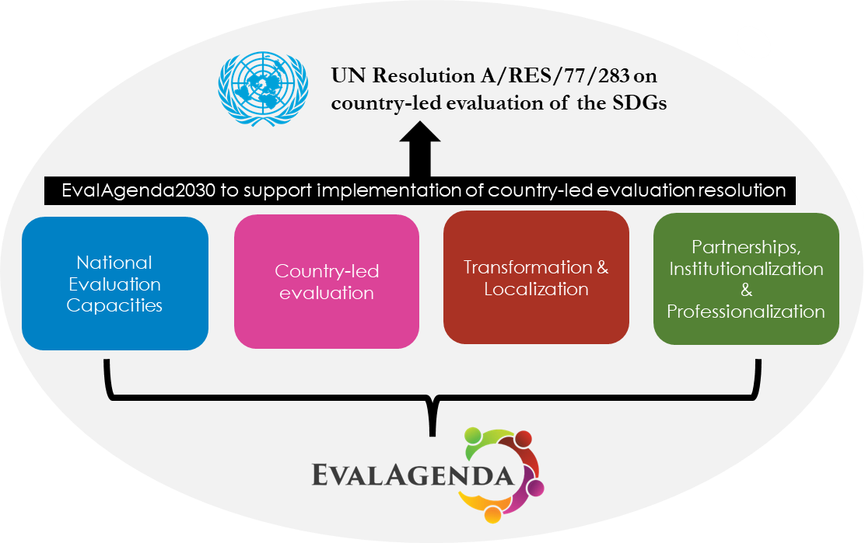
The Forum is organised in four themes forming the foundation for the development and adoption of EvalAgenda2030 which will see the implementation of Resolution A/RES/77/283 on country-led evaluation of the SDGs. The themes identified are:

The Forum is organized over four days with the following issues and themes covered:
DAY 1 | GEF pre-conference workshops & EvalYouth Summit | - Evaluation professionalization  - Localization & institutionalization of evaluation practices  - VOPEs role in pushing the UN Resolution forward  - Transformative, progressive evaluation practices  - Generative AI  - Evaluation connecting national priorities with SDGs | - EvalYouth Summit
DAY 2 | GEF opening event in plenaries and thematic panels | - Evaluating the SDGs and building national evaluation capacities  - How would Parliamentarians push for the institutionalization of policy evaluation  - Voluntary National Reviews and Gender Equality  - Decolonizing evaluation practice  - Gender transformative evaluation  - Youth leading evaluation
DAY 3 | Plenaries, thematic panels and working sessions | - EvalAgenda2030 and Progressive & Contemporary Evaluation Practice  - UN Resolution – The way forward  - Evaluation to connect national priorities with the SDGs  - Institutionalizing evaluation capacities – lessons learnt  - Partnerships to evaluate the Agenda 2030 – eight years since the launch of the SDGs  - Sulley Gariba memorial lecture discussion
DAY 4 | EvalPartners, networks & partners | - Launching the EvalAgenda 2030  - GEF 2024 Declaration (the Rabat Declaration) | - Half day internal EvalPartners and Networks meetings

To engage with the EvalPartners Global Evaluation Forum, reach out to:
Forum coordinator, Kassem El-Saddik:
gef2024coordinator@gmail.com

